AI-Based Household Wealth Estimation System Using Docker Compose and CI/CD
DEVOPS PROJECT REPORT
Submitted By
Kunal Mahore
B.Tech Computer Science Engineering
Academic Year: 2025–26

Table of Contents
Chapter 1 — Introduction
1.1 Project Overview
1.2 Problem Statement
1.3 Objectives
1.4 Scope
Chapter 2 — System Requirements
2.1 Hardware Requirements
2.2 Software Requirements
Chapter 3 — Workflow
Chapter 4 — Implementation
4.1 Setup Steps
4.2 Configurations
4.3 Commands Used
4.4 Dockerfile
4.5 Docker Compose
4.6 GitHub Actions CI/CD
4.7 GitHub Repository
Chapter 5 — Results and Output
Chapter 6 — Future Scope
Chapter 7 — Conclusion

Chapter 1 — Introduction

1.1 Project Overview
The AI-Based Household Wealth Estimation System is a DevOps-oriented deployment project that combines Artificial Intelligence, Computer Vision, Docker containerization, Docker Compose orchestration, and CI/CD automation.
The system predicts household wealth categories by analyzing exterior images of houses. The project uses an EfficientNet-B0 deep learning model trained using PyTorch. The prediction categories include low wealth, medium wealth, and high wealth.
The project was designed using a microservices architecture where the frontend and backend run as separate containers. The frontend was developed using Streamlit and the backend was developed using FastAPI. Docker Compose manages both services and provides automatic networking and orchestration.
GitHub Actions was used to automate Continuous Integration and Continuous Deployment workflows. The CI/CD pipeline automatically builds Docker images and pushes them to Docker Hub whenever code changes are pushed to the repository.
The major objective of this project is to demonstrate how modern DevOps practices can simplify deployment, improve reproducibility, and automate delivery pipelines for AI applications.

1.2 Problem Statement
Traditional Machine Learning projects are usually executed in notebooks or local environments. These projects often face problems such as dependency conflicts, inconsistent environments, deployment difficulties, and lack of scalability.
Deploying AI applications manually requires installing dependencies individually on each system. This process becomes difficult to manage and error-prone.
The project solves these problems using DevOps technologies such as Docker, Docker Compose, GitHub Actions, and CI/CD automation. The application can now run consistently across multiple systems without dependency issues.

1.3 Objectives
The objectives of the project are:
• To implement Docker containerization for AI services.
• To develop a microservices-based architecture.
• To create isolated frontend and backend services.
• To implement Docker Compose orchestration.
• To automate image builds using GitHub Actions.
• To implement CI/CD workflows.
• To improve deployment reproducibility.
• To demonstrate modern DevOps practices.
• To integrate Artificial Intelligence with deployment automation.

1.4 Scope
The project scope includes:
• AI image classification
• Containerized deployment
• Docker networking
• Docker Compose orchestration
• CI/CD automation
• Docker Hub deployment
• Frontend-backend communication
• Automated build workflows
The project can be further extended using Kubernetes, cloud deployment platforms, monitoring systems, and scalable infrastructure.

Chapter 2 — System Requirements

2.1 Hardware Requirements
Component | Requirement
Processor | Intel Core i5 or equivalent
RAM | 8 GB minimum
Storage | 20 GB free space
Internet | Required
GPU | Optional

2.2 Software Requirements
Software | Purpose
Python 3.11 | Programming language
Docker | Containerization
Docker Compose | Container orchestration
Git | Version control
GitHub | Repository hosting
FastAPI | Backend framework
Streamlit | Frontend framework
PyTorch | Deep learning framework
GitHub Actions | CI/CD automation

Chapter 3 — Workflow
Step 1 — Dataset Collection
House exterior image datasets were collected and categorized into low, medium, and high wealth classes.
Step 2 — Data Preprocessing
Images were resized, normalized, and converted into tensors using PyTorch transformations.
Step 3 — Model Training
The EfficientNet-B0 convolutional neural network model was trained using PyTorch. The model learned image patterns related to wealth estimation.
Step 4 — Model Saving
The trained model was saved as a .pth file for deployment.
Step 5 — Backend Development
A FastAPI backend service was developed to load the model, receive image uploads, preprocess images, and return predictions.
Step 6 — Frontend Development
A Streamlit frontend was developed for image upload, prediction visualization, and confidence score display.
Step 7 — Docker Containerization
Separate Dockerfiles were created for frontend and backend services.
Step 8 — Docker Compose Orchestration
Docker Compose orchestrates frontend and backend containers and creates shared networking automatically.
Step 9 — CI/CD Automation
GitHub Actions automatically builds Docker images and pushes them to Docker Hub whenever code changes are pushed to GitHub.
Step 10 — Deployment
The project runs using docker compose up command which launches all services automatically.

Chapter 4 — Implementation

4.1 Setup Steps
1. Install Docker and Docker Compose.
2. Clone the GitHub repository.
3. Create frontend and backend requirements files.
4. Build Docker images.
5. Run containers using Docker Compose.
6. Open frontend in browser.

4.2 Configurations
Frontend Port: 8501
Backend Port: 8000
Docker Compose automatically creates a shared bridge network. The frontend communicates with backend using service name based DNS resolution.
Example:
http://backend:8000

4.3 Commands Used
docker compose build
docker compose up
docker compose up --build
docker compose down
docker ps
docker images
docker network ls
docker compose logs

4.4 Dockerfile
Separate Dockerfiles were created for frontend and backend services.
Backend Dockerfile responsibilities:
• Install backend dependencies
• Copy source code
• Expose backend port
• Start FastAPI service
Frontend Dockerfile responsibilities:
• Install Streamlit dependencies
• Copy frontend source code
• Expose frontend port
• Start Streamlit application

4.5 Docker Compose
Docker Compose manages multiple containers using a single YAML configuration file.
Responsibilities:
• Build frontend and backend images
• Create containers
• Create shared bridge network
• Manage startup dependencies
• Expose ports
• Enable inter-container communication

4.6 GitHub Actions CI/CD Workflow
GitHub Actions automates Continuous Integration and Continuous Deployment workflows.
Workflow steps:
• Checkout repository
• Login to Docker Hub
• Build backend image
• Build frontend image
• Push images to Docker Hub
The pipeline runs automatically whenever code is pushed to the main branch.

4.7 GitHub Repository
The complete project source code was managed using Git and GitHub.
The repository contains:
• Frontend source code
• Backend source code
• Dockerfiles
• Docker Compose configuration
• GitHub Actions workflow
• Documentation
• README file

Backend Dockerfile
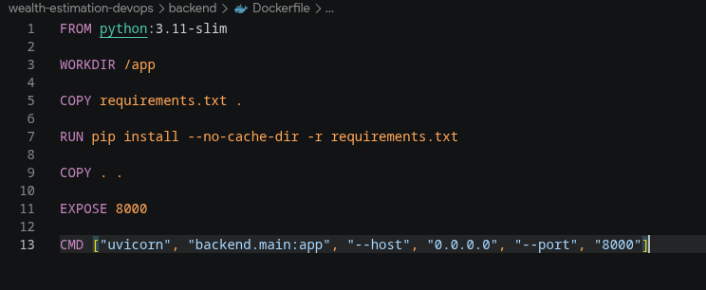

Frontend Dockerfile
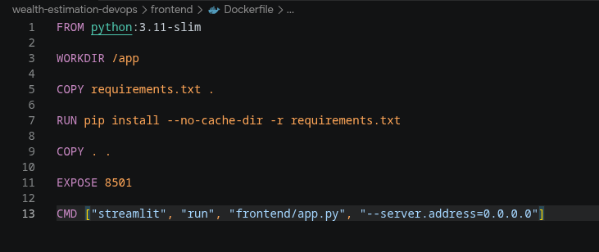

Docker Compose File
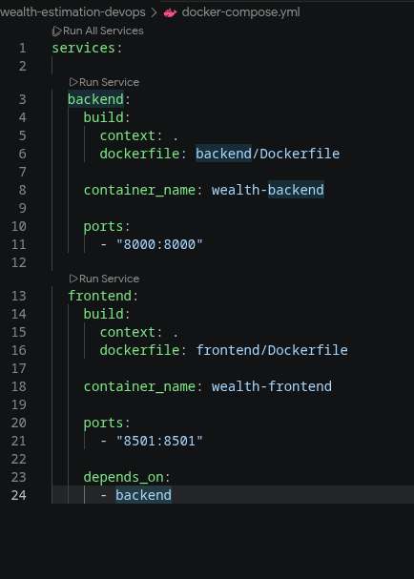

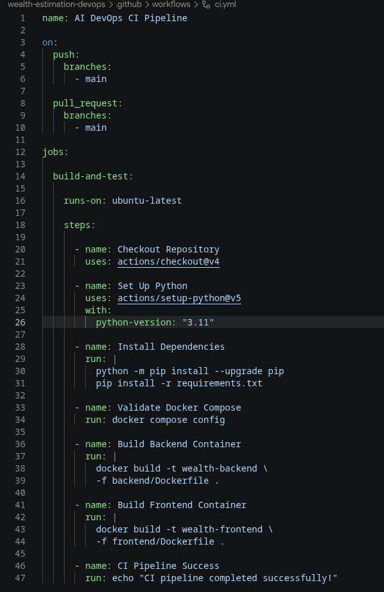
CI Config File

Chapter 5 — Results and Output
The project was successfully implemented and tested.
Results achieved:
• Docker images were successfully created.
• Frontend and backend containers were launched successfully.
• Docker Compose orchestration worked correctly.
• Frontend communicated with backend through Docker networking.
• GitHub Actions CI/CD workflow executed successfully.
• Docker images were pushed to Docker Hub.
• The AI model generated wealth predictions successfully.
Example Prediction Output:
Prediction: High
Confidence: 97%

Screenshots:
• Docker image build output
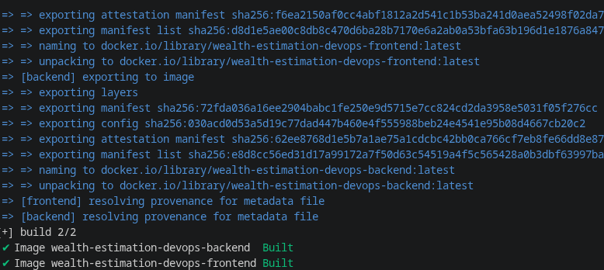

• Running containers
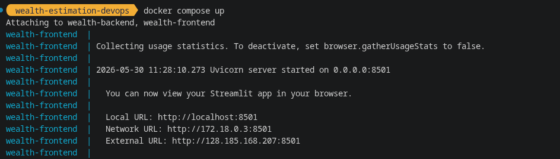
• Streamlit frontend
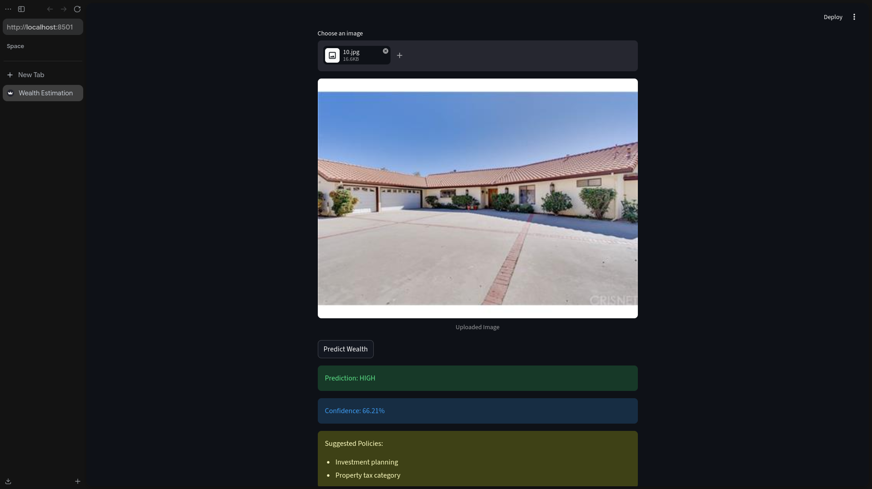

• GitHub Actions workflow success
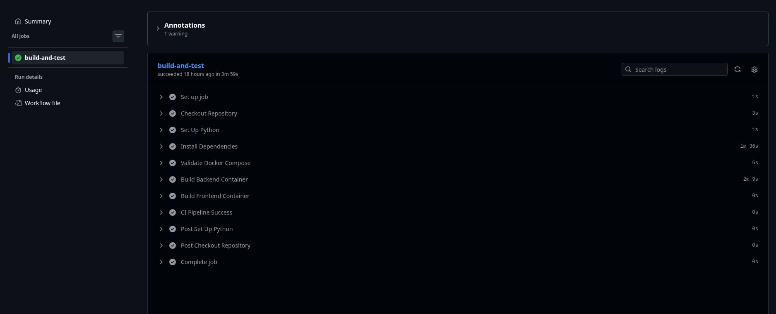
• Docker Hub repositories

Chapter 6 — Future Scope
Future improvements include:
• Kubernetes orchestration
• Cloud deployment using AWS or Azure
• Jenkins integration
• Monitoring dashboards
• Auto-scaling infrastructure
• GPU acceleration
• Database integration
• User authentication
• Production-grade deployment
The project can be transformed into a large-scale AI deployment platform using modern DevOps technologies.

Chapter 7 — Conclusion
The project successfully demonstrated how Artificial Intelligence applications can be integrated with modern DevOps practices.
The project achieved:
• Docker containerization
• Docker Compose orchestration
• CI/CD automation
• Docker networking
• Automated deployment workflows
• Microservices architecture
Technologies learned:
• Docker
• Docker Compose
• GitHub Actions
• FastAPI
• Streamlit
• PyTorch
• Container orchestration
• CI/CD automation
The final outcome was a fully containerized AI deployment system capable of automated builds and scalable execution using DevOps methodologies.

